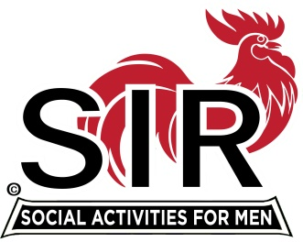
Las Trampas Branch 116
BEC Meeting Agenda
October 18, 2021, 8:30 AM via Zoom
[Zoom login at the bottom of the agenda]
The Mission of SIR is to enhance the lives of our members through fun activities, events and luncheons – while making friends for life.

8:30 am Call to order; Secretary confirm a quorum
8:35 Secretary –Paul Ramacciotti – Approval of September 20, 2021 BEC meeting minutes
8:40 Treasurer –/Alan Fitzgerald – Report
8:45 Standing Reports
- Membership – Phil Goff
- RAMP Department Head Reports:
- Recruitment
- Activity Coordinator
- Member relations
- Publicity
- Covid Compliance [Kevin Donahue]

9:00 Big SIR Report – Sam Beret

- October 18 monthly meeting agenda
- News from other branches

9:10 Little SIR Report - Fred Wachowicz
1. Speaker
2. Birthday Boys
3. Diversity Team Report

9:20 Old Business

9:25 New Business
- Attendance survey results [Mike Schneider]
- November 15 meeting – Zoom? Boundary Oak?
3- No-host Cocktail Party, December 15, Boundary Oak?

10:00 Adjourn; Next BEC Meeting, November 15, 2021

Zoom Link:

https://us02web.zoom.us/j/89269854543
Meeting ID: 892 6985 4543
Passcode: 826904

Dial-in: (669) 900-9128

